**Angular Advanced**

**OnPush Change Detection**

**EG: It is especially applied to Child components.**

**HostListener & HostBinding**

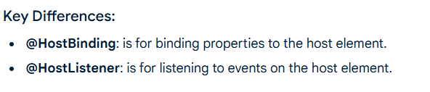

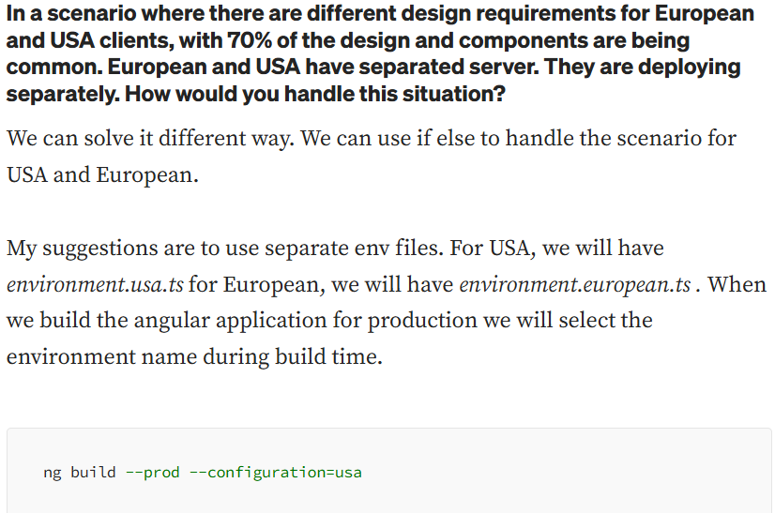

**Async Pipe**

**How to handle multiple http requests in Angular?**

**map vs mergemap vs switchmap vs concatmap in angular**

**Track By:**

**Validation in Angular**

**Error Handling in Angular**

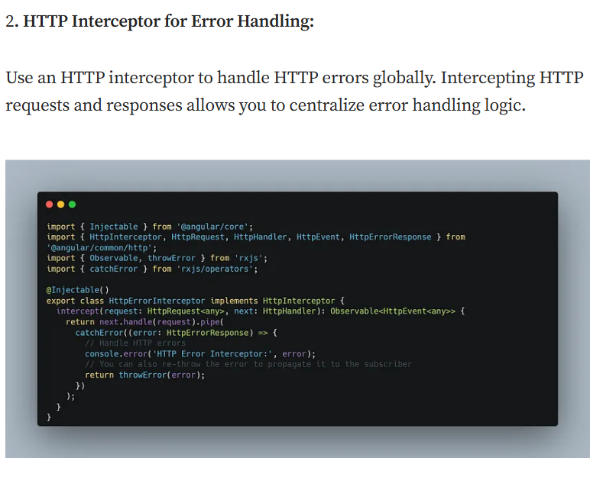

**SCENARIO BASED QUESTIONS**

